# Spinach and Red Shen Choy in Garlicky Broth Recipe

[SHAO Z.](https://www.seriouseats.com/user/profile/shaoz)

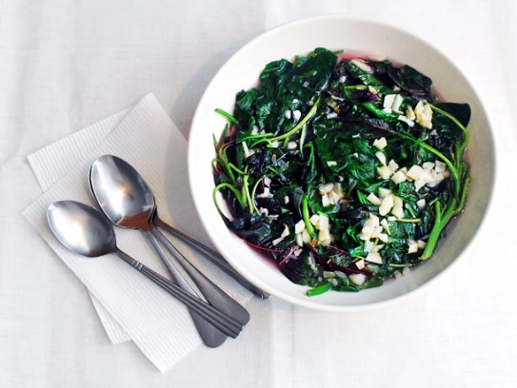

Tender baby spinach and red shen choy are briefly simmered just until wilted, then served very simply with a broth flavored with lightly browned garlic. I can't think of an easier way to put a delicious side dish on the table.

**Note:** Shen Choy is also known as red amaranth and can be found in most Asian markets. If unavailable, you can use more spinach or any semi-tender green like watercress, iceberg lettuce, or snow pea shoots.

* **YIELD:**Serves 3 to 4 as a side dish
* Kosher salt
* 6 ounces (about 1 1/2 quarts tightly packed leaves) baby spinach, trimmed and washed
* 6 ounces (about 1 1/2 quarts tightly packed leaves) red shen choy, trimmed and washed (see note)
* 1 tablespoon vegetable, canola, or peanut oil
* 6 cloves garlic, roughly chopped
* 1 1/2 cups homemade or store-bought low-sodium chicken or vegetable stock

1. Bring a large pot of salted water to a boil. Add the shen choy and boil for 1 minute. Add spinach and continue boiling 1 minute longer. Drain well and place in a large shallow serving bowl.
2. Heat the oil in a small saucepan over medium heat until shimmering. Add the garlic and cook, stirring, until it’s a little soft and starting to turn golden brown, about 5 minutes. Add the broth, bring it to a boil, and season it with salt if needed. Pour the hot broth with the garlic on top of the greens. Serve immediately.

<https://www.seriouseats.com/recipes/2014/05/spinach-red-shen-choy-broth-garlic-recipe.html>